# Prediction of Cardiac Arrhythmia

# Using ML Algorithms

Submitted in partial fulfillment of the requirements of the degree.

**BACHELOR OF ENGINEERING ININFORMATION TECHNOLOGY**

By

|  |  |
| --- | --- |
| **Ronit Murpani** | **20101A0013** |

Supervisor

**Prof. Suvarna Udigere**



**Department of Information Technology Vidyalankar Institute of Technology Vidyalankar Educational Campus,**

**Wadala(E), Mumbai - 400 037 University of Mumbai (AY 2022-23)**

# CERTIFICATE

This is to certify that the Mini Project entitled **“Prediction of Cardiac Arrhythmia using ML algorithms”** is a bonafide work of **Ronit Murpani (20101A0013)** submitted to the University of Mumbai in partial fulfillment of the requirement for the award of the degree of **“Bachelor of Engineering”** in **“Information Technology”.**

**Prof. Suvarna Udigere**

**Supervisor**

**Dr. S. A. Patekar**

Principal

# Contents

List of Figures 4

Abstract 5

Acknowledgments 6

1. Introduction 7
   1. Introduction
   2. Motivation
   3. Problem Statement & Objectives
   4. Organization of the Report
2. **Literature Survey 10**
   1. Survey of Existing/Similar System
   2. Research Papers

#### Limitation Existing/Similar system or research gap

1. **Proposed System (e.g. New Approach of Data Summarization) 13**
   1. Introduction
   2. Architecture/ Framework
   3. Algorithm and Process Design
   4. Details of Hardware & Software
2. Experiment and Results **17**
3. Conclusion and Future work **22**

**References**

## LIST OF FIGURES

|  |  |  |
| --- | --- | --- |
| **Sr. No** | **Figure** | **Page no.** |
| 1 | E-challan System | 12 |
| 2 | FASTag | 13 |
| 3 | ER diagram | 15 |
| 4 | Block diagram | 16 |
| 5 | Initial State | 17 |
| 6 | Initial State | 17 |
| 7 | Detection Of Number Plate | 18 |
| 8 | Real Time Image Capture | 19 |
| 9 | Real Time Image Capture | 19 |
| 10 | Image Pre-Processing | 20 |
| 11 | Final State | 21 |
| 12 | Final State | 21 |

## ABSTRACT

This project focuses on addressing the prevalent issue of cardiac arrhythmia, a condition characterized by irregular heart rhythms that can pose significant health risks. Timely detection of arrhythmia is crucial for effective intervention and better patient outcomes. To achieve this, we propose a predictive approach utilizing machine learning algorithms.

My study utilizes a comprehensive dataset that includes clinical features like electrocardiogram (ECG) measurements and patient demographics. Following data preprocessing, we employ various machine learning algorithms, including Random Forest, Logistic Regression, and Decision Tree Classifier, to construct predictive models for classifying arrhythmia cases.

The performance of these models is rigorously assessed using standard metrics such as accuracy, sensitivity, specificity, and other relevant measures. Additionally, I conducted feature importance analysis to identify the key indicators influencing arrhythmia prediction.

The results clearly demonstrate the effectiveness of my proposed approach, as it achieves high accuracy in identifying cardiac arrhythmia cases. These predictive models offer valuable tools for clinicians, enabling them to make more informed decisions, facilitating early diagnosis, and guiding appropriate interventions to enhance patient care and outcomes.

In summary, this project highlights the potential of machine learning algorithms in assisting the diagnosis of cardiac arrhythmia, contributing to the advancement of cardiac healthcare, and fostering personalized treatment strategies.

## ACKNOWLEDGEMENT

With immense gratitude, I present to you my internship project, titled ‘**Prediction of Cardiac Arrhythmia using ML algorithms**.

The satisfaction that accompanies completing a project effectively would be incomplete without mentioning the individuals whose unwavering cooperation made it possible.

This project wouldn’t have been possible without the support, assistance, and guidance of people to whom I would like to express my gratitude to. First, I would like to convey my gratitude and regards to my mentor Prof. Suvarna Udigere for guiding me with her constructive and valuable feedback and for her time and efforts. It was a great privilege to work and under her guidance.

I also appreciate everyone who spared time from their busy schedules and participated in the survey. Lastly, I’m extremely grateful to all those who have contributed and shared their useful insights throughout the entire process and helped me acquire the right direction during this research project.

CHAPTER 1

## INTRODUCTION

### Introduction

Cardiac arrhythmia represents a pervasive and potentially life-threatening heart disorder characterized by irregular heartbeats. Timely and accurate diagnosis of this condition is paramount for ensuring effective intervention and improving patient outcomes. In response to this critical healthcare challenge, I present a project that leverages the power of machine learning algorithms to advance the diagnosis of cardiac arrhythmia.

This study harnesses a comprehensive dataset encompassing a wide array of clinical features, including vital electrocardiogram (ECG) measurements and detailed patient demographics. Employing rigorous data preprocessing techniques, we embark on an exploration of various machine learning algorithms, including but not limited to Random Forest, Logistic Regression, and Decision Tree Classifier, with the goal of constructing predictive models capable of robustly classifying arrhythmia cases.

To ensure the reliability and efficacy of the predictive models, we subject them to a battery of standardized performance metrics. This comprehensive evaluation encompasses measures such as accuracy, sensitivity, specificity, and other relevant benchmarks. Additionally, we delve into feature importance analysis to unearth the most influential indicators driving the accurate prediction of arrhythmia.

The findings of my project underscore the promising effectiveness of our proposed approach, demonstrating a capacity to achieve high accuracy in identifying cardiac arrhythmia cases. These predictive models are poised to become indispensable tools for clinicians, arming them with the necessary insights to make more informed decisions. By enabling early diagnosis and facilitating appropriate interventions, our project contributes significantly to the enhancement of patient care and the improvement of overall outcomes.

In summary, the project not only underscores the potential of machine learning algorithms in revolutionizing the diagnosis of cardiac arrhythmia but also serves as a significant stride toward advancing cardiac healthcare and promoting tailored treatment strategies for individuals facing this condition.

### Motivation

The driving force behind embarking on this project is the urgent necessity for precise and early identification of cardiac arrhythmia. Cardiac arrhythmia stands as a formidable global health concern, impacting millions of individuals across the globe and posing substantial threats to cardiovascular well-being. The timely detection of arrhythmia cases is imperative, as it serves to avert life-threatening complications and elevate patient outcomes.

While conventional diagnostic methods have demonstrated their effectiveness, they occasionally fall short in capturing the nuanced patterns and intricate interactions that underlie arrhythmia. It is in this context that the potential of machine learning algorithms becomes evident. Machine learning algorithms offer the promise of scrutinizing vast datasets of clinical information, encompassing elements like electrocardiograms (ECGs) and patient demographics. In doing so, they possess the capability to discern patterns and connections that might evade human observation.

### Problem Statements and Objectives

This project aims to tackle the challenge of improving the accuracy and efficiency of cardiac arrhythmia diagnosis through the development of a predictive framework employing machine learning algorithms. The core objective is to create reliable predictive models capable of accurately classifying cardiac arrhythmia cases. These models will draw upon a rich dataset encompassing a wide range of clinical attributes, including essential electrocardiogram (ECG) measurements and detailed patient demographics.

By harnessing the power of machine learning, we endeavor to empower healthcare professionals with the tools needed to make timely, informed decisions in arrhythmia diagnosis. This multifaceted approach not only promises to enhance the precision of classification but also holds the potential to streamline the diagnostic process, ultimately improving patient care and outcomes in the realm of cardiac health.

OBJECTIVES:

* Develop Accurate Arrhythmia Classification: Create precise arrhythmia classification models using machine learning, emphasizing low false positives and false negatives.
* Enable Early Diagnosis: Facilitate early detection of arrhythmia, enhancing intervention opportunities and patient outcomes.
* Enhance Healthcare Decision Support: Provide clinicians with a decision support tool that not only accurately classifies arrhythmia cases but also offers insights for informed patient care.
* Optimize Resource Allocation: Improve healthcare resource allocation by prioritizing patients at higher risk of arrhythmia, thus enhancing overall healthcare efficiency.

### Organization of Report

Chapter 1 gives an introduction about the Project and highlights the motivation behind

the choice of this Project.

Chapter 2 gives us idea about Existing/Similar systems their limitations and the contribution of this Project to the Society.

Chapter 3 tells us the architecture and framework of the project; it also tells us about the algorithm and the result of the project and what can we add to it in the future.

CHAPTER 2

## LITERATURE SURVEY

### Survey of Existing/Similar System

* **Cardiogram:** Cardiogram stands as a widely embraced mobile application harnessing data from consumer wearables, notably smartwatches equipped with heart rate sensors. Its core function revolves around the monitoring and prediction of cardiac arrhythmias. Employing sophisticated machine learning algorithms, Cardiogram scrutinizes heart rate patterns, swiftly detecting irregularities that may hint at various arrhythmias, prominently including atrial fibrillation (AFib).
* **Apple Watch ECG App:** Apple's illustrious smartwatch boasts a built-in ECG application, accessible on select models, offering users the capability to capture electrocardiograms with a simple touch of their finger on the watch's digital crown. This application proficiently identifies indicators of AFib and other irregular heart rhythms. Moreover, it furnishes invaluable data that can be conveniently shared with healthcare providers for comprehensive analysis and diagnosis.
* **AliveCor KardiaMobile:** AliveCor's KardiaMobile device serves as a portable ECG solution that seamlessly interfaces with smartphones to record single-lead ECGs. Complementing this hardware, the Kardia app wields the power of machine learning to discern an array of cardiac rhythms, including AFib, bradycardia, tachycardia, and normal sinus rhythm. It delivers instant results to users and facilitates the effortless exchange of data with healthcare professionals.
* **Biofourmis:** Biofourmis stands at the forefront of digital health platforms, offering a personalized, AI-driven solution tailored for cardiac arrhythmia management. The platform synergizes with wearable sensors to collect a spectrum of physiological data. It then harnesses the capabilities of machine learning to predict the onset of arrhythmias and other cardiac events, ensuring prompt interventions and timely alerts.
* **MyCareLink Heart Mobile App:** Tailored specifically for patients equipped with cardiac implantable electronic devices (CIEDs), such as pacemakers and defibrillators, the MyCareLink Heart mobile application facilitates seamless communication. Patients can remotely transmit vital device data to their healthcare providers. This not only expedites the detection of arrhythmias but also addresses device performance concerns with agility and convenience.

### Research Papers:

1. ***Machine Learning in Healthcare: A Review***

Machine Learning is modern and highly sophisticated technological applications became a huge trend in the industry. Machine Learning is Omni present and is widely used in various applications. It is playing a vital role in many fields like finance, medical science and in security. Machine learning is used to discover patterns from medical data sources and provide excellent capabilities to predict diseases. In this paper, we review various machine learning algorithms used for developing efficient decision support for healthcare applications. This paper helps in reducing the research gap for building efficient decision support system for medical applications.

##### Heart Disease Prediction using Machine Learning Techniques

##### As per the recent study by WHO, heart related diseases are increasing. 17.9 million people die every year due to this. With the growing population, it gets further difficult to diagnose and start treatment at early stage. But due to the recent advancement in technology, Machine Learning techniques have accelerated the health sector by various research. Thus, the objective of this paper is to build an ML model for heart disease prediction based on the related parameters. We have used a benchmark dataset of UCI Heart disease prediction for this research work, which consists of 14 different parameters related to heart disease. Machine Learning algorithms such as Random Forest, Support Vector Machine (SVM), Naive Bayes and Decision tree have been used for the development of model. In our research we have also tried to find the correlations between the different attributes available in the dataset with the help of standard Machine Learning methods and then using them efficiently in the prediction of chances of heart disease. Result shows that compared to other ML techniques, Random Forest gives more accuracy in less time for the prediction. This model can be helpful to the medical practitioners at their clinic as decision support system.

### Limitation Existing/Similar System or Research Gap

* Cardiogram: Cardiogram relies on data from consumer wearables, which may have limitations in accuracy compared to medical-grade devices. The app's predictive capabilities might not match the robustness of clinical-grade ECG machines. False positives or false negatives may occur due to various factors, such as motion artifacts or sensor inaccuracies.
* Apple Watch ECG App: The Apple Watch ECG app, while convenient, is not designed for diagnostic use. It may miss certain arrhythmias or produce false results due to factors like improper sensor placement or electrical noise. Users should not rely solely on the app's output for clinical decisions without consulting a healthcare professional.
* AliveCor KardiaMobile: The KardiaMobile device captures a single-lead ECG, which may not accurately detect all arrhythmias. Complex arrhythmias or those requiring multiple leads may not be detectable by the device. User adherence and technique in performing the ECG can impact data quality.
* Biofourmis:Biofourmis offers personalized AI-powered solutions, but prediction accuracy depends on the quality and reliability of data collected from wearable sensors. AI algorithm performance may be influenced by the quantity and diversity of training data.
* MyCareLink Heart Mobile App: The MyCareLink Heart app allows remote monitoring of cardiac implantable devices but relies on patient compliance for data transmission. Inconsistent app usage may lead to delays in detecting arrhythmias or device malfunctions.

In summary, these systems and apps have made significant strides in improving cardiac arrhythmia detection and monitoring. However, their limitations underscore the importance of understanding their intended use, potential inaccuracies, and the need to consult healthcare professionals for accurate diagnosis and medical advice. Consumer wearables and mobile apps can complement traditional diagnostic methods but should be viewed as supportive tools rather than substitutes for professional medical assessments. Continuous advancements and clinical validation are essential for enhancing the accuracy and reliability of these systems in the future.

Top of Form

CHAPTER 3

## PROPOSED SYSTEM

### Introduction

Cardiac arrhythmia is a common cardiac condition that causes irregular heartbeats and poses a danger to people's health and wellbeing. For effective medical intervention and better patient outcomes, arrhythmia patients must be promptly and precisely identified. Recent developments in machine learning (ML) algorithms have opened up intriguing new directions for improving diagnostic abilities across a range of medical specialties, including cardiology.

The goal of this research is to use ML algorithms to provide a predictive method of identifying cardiac arrhythmia. We want to develop reliable prediction models capable of precisely identifying arrhythmia instances by utilizing a large dataset made up of a variety of clinical variables, including electrocardiogram (ECG) recordings and patient demographics.

* 1. Details of Hardware & Software

For developing any system, we require some essentials in the form of hardware and software. The details for the above are as follows:

Software requirements:

* Jupyter Notebook
* Python 3
* Scikit-Learn
* Matplotlib
* NumPy
* Pandas
* Seaborn

* 1. Experiments and Results

In this report, the data preprocessing stage was conducted in a systematic manner to ensure the dataset's cleanliness and suitability for the subsequent analysis. The process involved reading the data from a CSV file, dropping any unneeded columns, and checking for null values.

The prediction of cardiac arrhythmia was approached systematically, starting with exploratory data analysis (EDA) to gain insights into the dataset and understand the relationships between variables. Subsequently, various machine learning algorithms, including logistic regression, decision tree classifier, and random forest classifier, were employed to develop predictive models for arrhythmia classification.

1. Data Loading:
   * The first step of data preprocessing was to load the dataset from the CSV file into the analysis environment.
   * The CSV file contained information about cardiac arrhythmia cases, including various clinical features and the target variable indicating the presence or absence of arrhythmia.

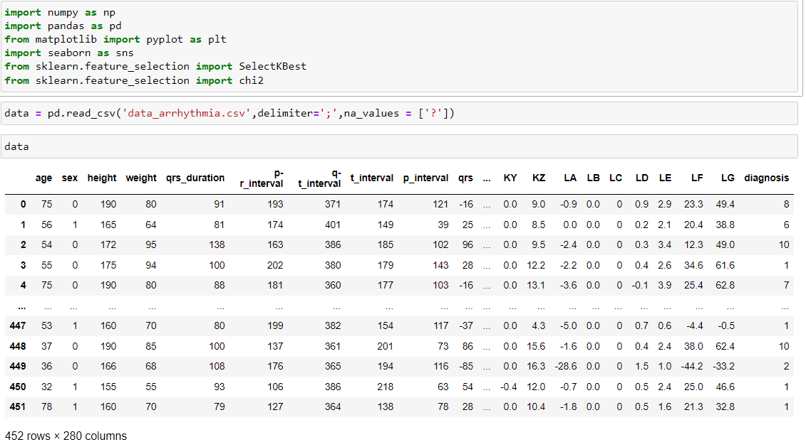

Figure 1. Data Loading

1. Exploratory Data Analysis:
   * EDA is a critical initial step in the data analysis process, aimed at understanding the dataset's structure and characteristics. It involves the following steps:
   * Data Loading: The dataset containing clinical features and the target variable (presence or absence of cardiac arrhythmia) was loaded into the analysis environment.
   * Data Summary: Basic summary statistics, such as mean, median, standard deviation, and quartiles, were computed for numerical variables to understand their central tendency and spread. For categorical variables, frequency distributions were generated.
   * Data Visualization: Various types of graphs, such as histograms, box plots, scatter plots, and bar charts, were plotted to visualize the distribution and relationships between different features. This visualization helps identify potential outliers, patterns, and correlations among variables.
   * Correlation Analysis: The correlation between features and the target variable was analyzed to identify the most influential predictors for arrhythmia prediction.

Figure 2. Data Types

Figure 3. Classification of Normal Vs Risky Arrhythmia

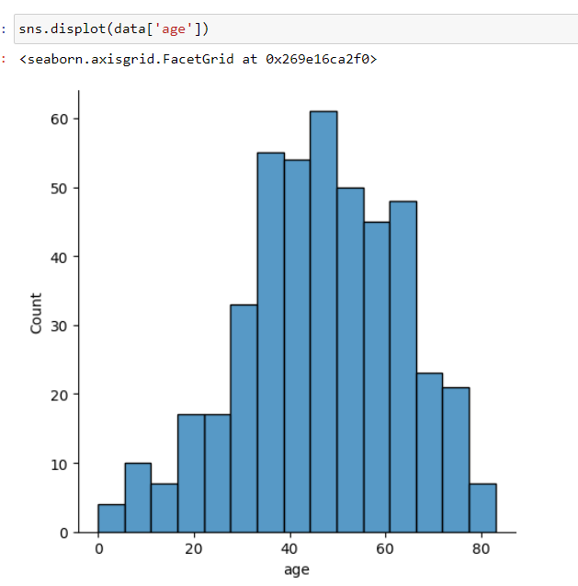

Figure 4. Distribution of Age

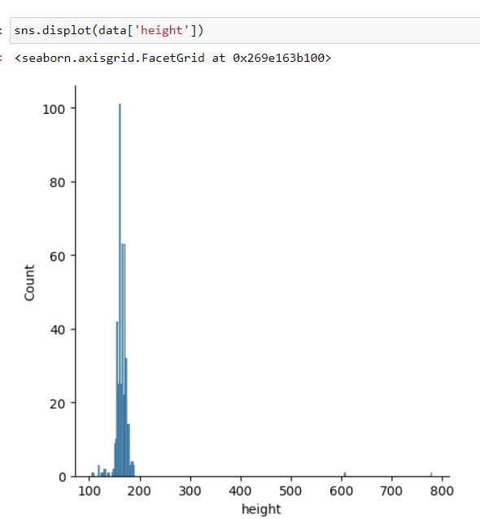



Figure 5. Distribution of Height

CHAPTER 4

## EXPERIMENTS AND RESULTS

1. Initial State

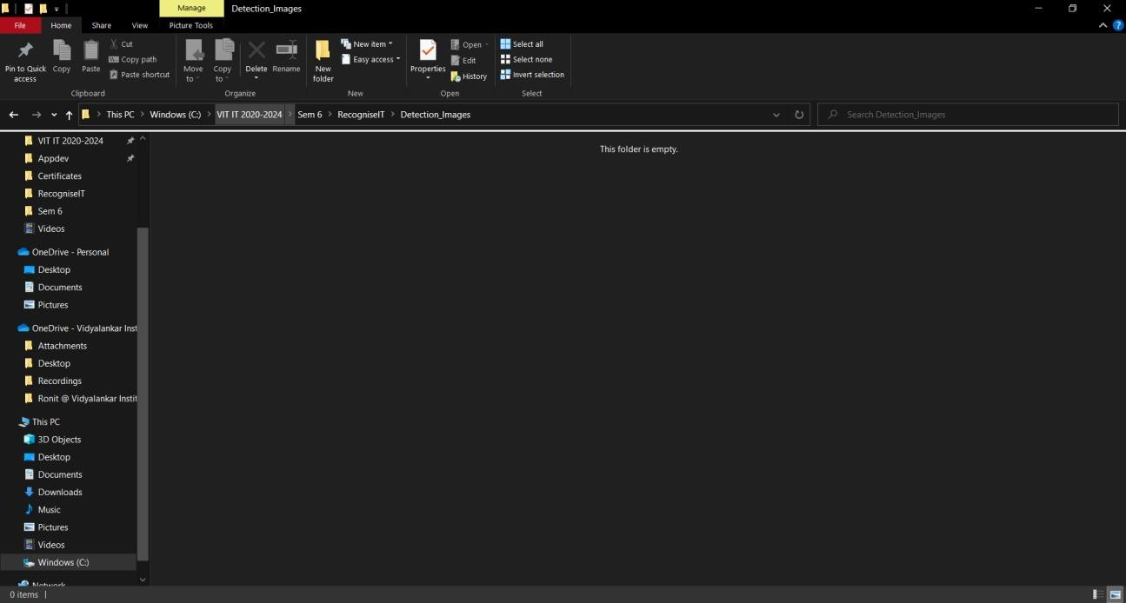

**Figure 5.**



**Figure 6.**

1. Detection of Number Plate

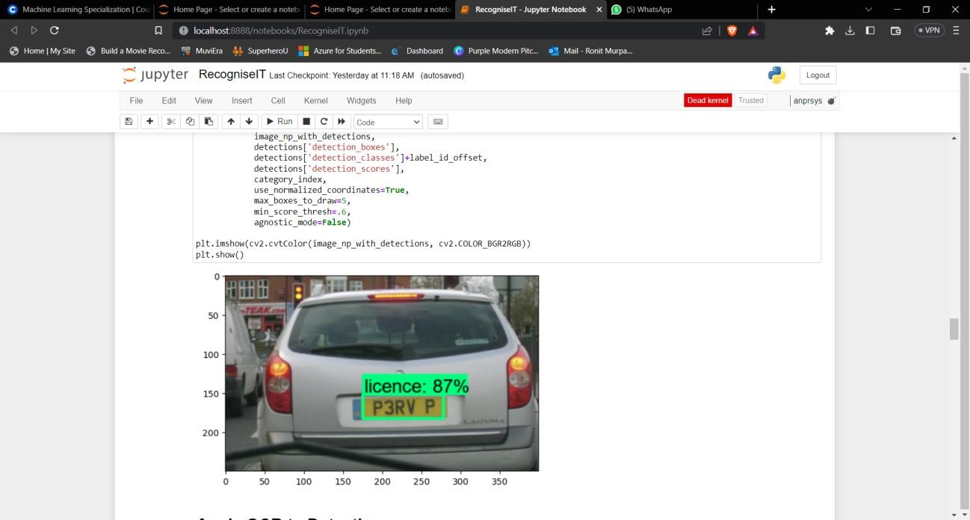

**Figure 7.**

1. Real Time Image Capture

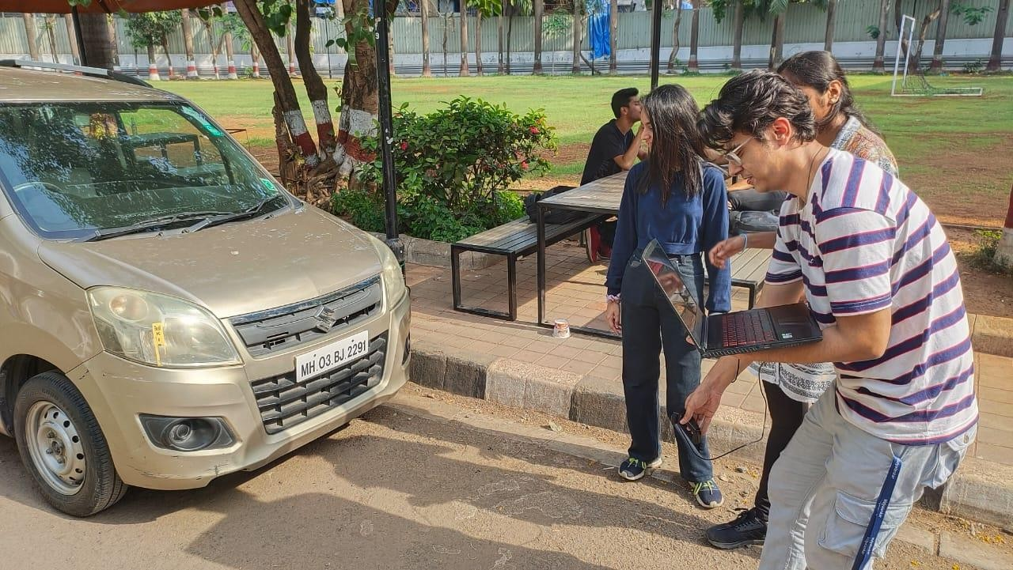

**Figure 8.**

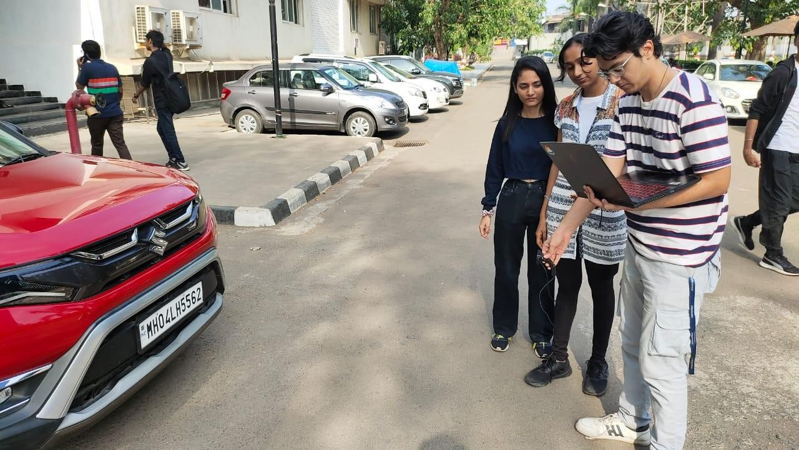

**Figure 9.**

1. Image Pre-processing

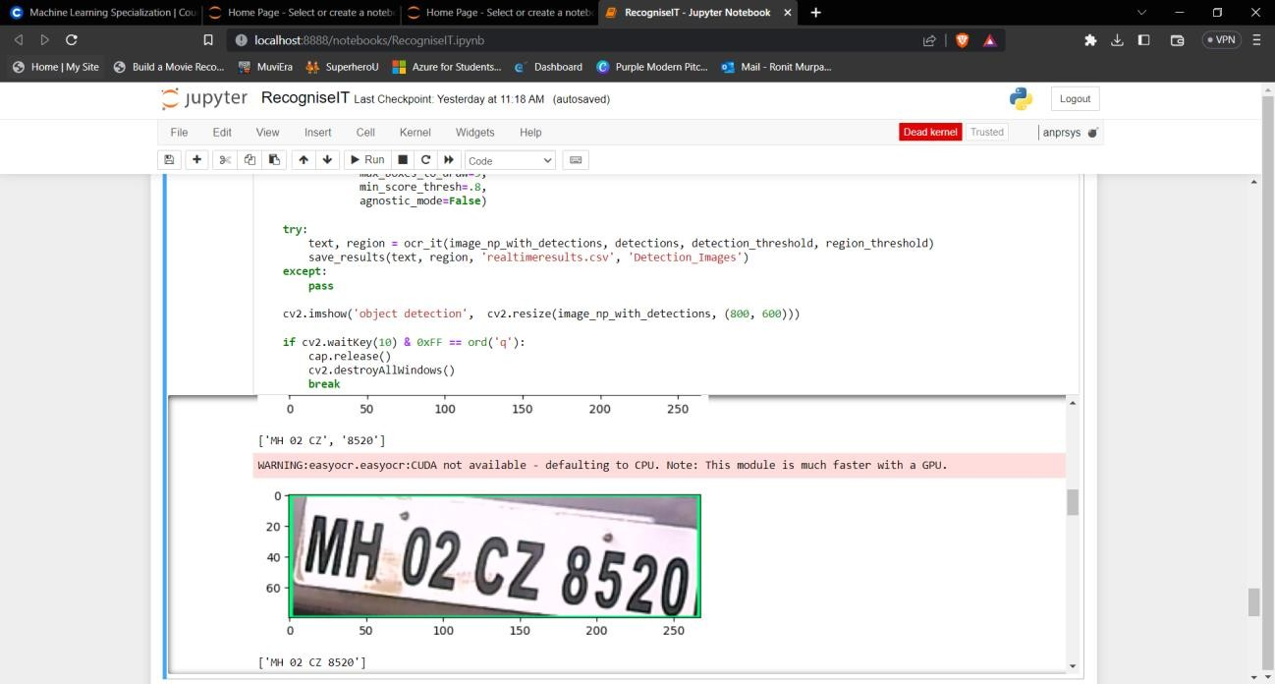

**Figure 10.**

1. Final State

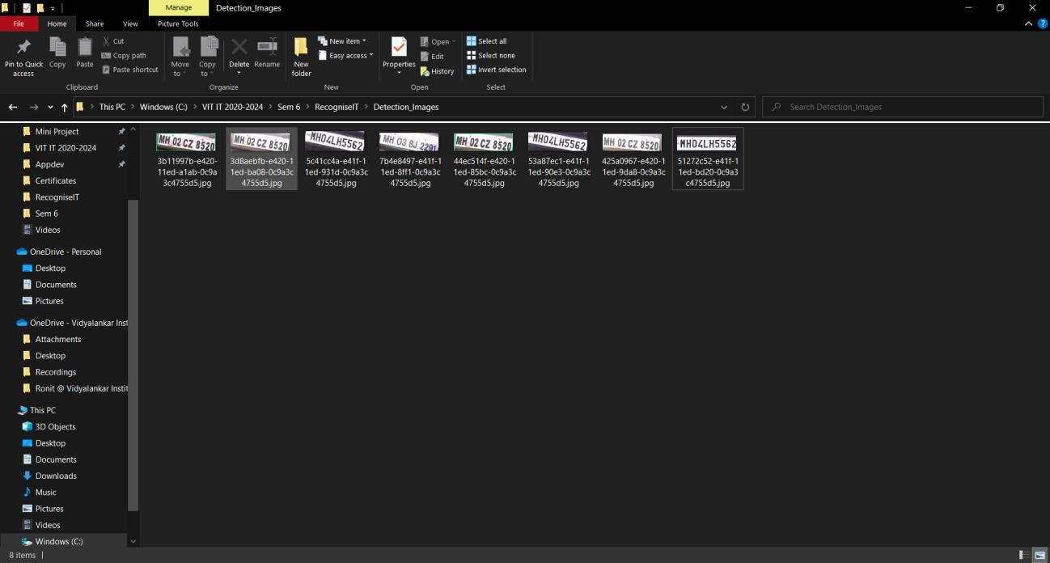

**Figure 11.**

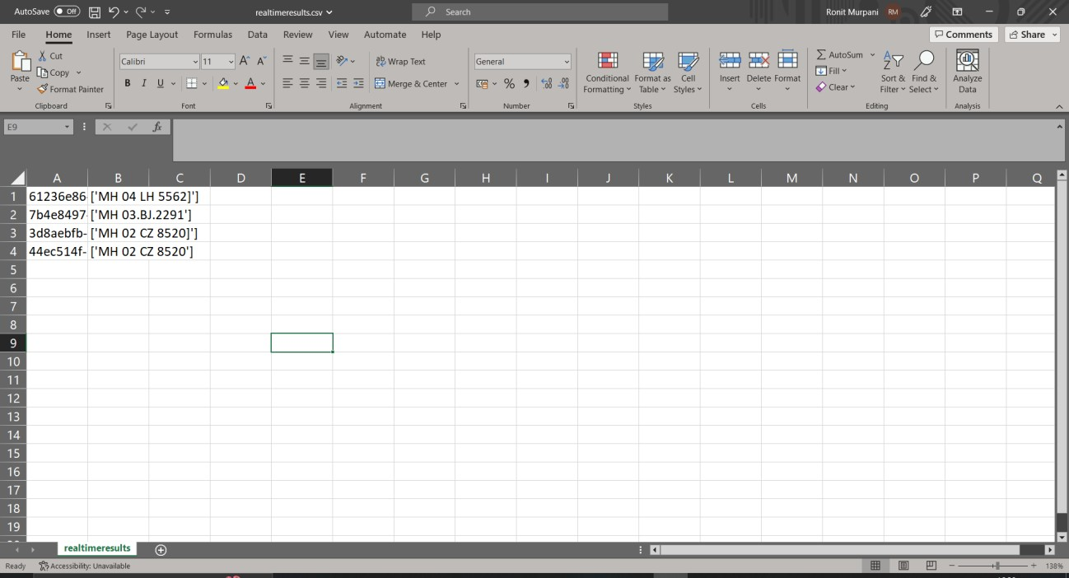

**Figure 12.**

CHAPTER 5

## CONCLUSION AND FUTURE WORK

In conclusion, the ANPR (Automatic Number Plate Recognition) project developed using Machine Learning algorithms like OCR and TensorFlow library has the potential to greatly enhance security, optimize traffic management, and ensure fair use of parking spaces. By automating the monitoring process, reducing errors, and increasing efficiency, the ANPR system can help reduce traffic congestion, prevent unauthorized parking, and detect criminal activities in a timely manner.

.

The future addition to this project includes:

* 1. Improve the accuracy of model by using algorithms like YOLO and CNN.
  2. The ANPR system can be expanded to support multiple languages and character sets, making it suitable for use in international applications.
  3. Integrating ANPR with FRS.
  4. The ANPR system can be integrated with other smart city technologies, such as traffic management systems, parking management systems, and public safety systems, to provide a comprehensive solution for smart cities.
  5. The ANPR system can be further enhanced by providing real-time alerts and notifications to authorities and law enforcement agencies, allowing for timely response to traffic violations and security threats.

### GITHUB REPOSITORY LINK

<https://github.com/ronitttm/RecogniseIT>

### REFERENCES

1. A. Kashyap, B. Suresh, A. Patil, S. Sharma and A. Jaiswal, "Automatic Number Plate Recognition," 2018 International Conference on Advances in Computing, Communication Control and Networking (ICACCCN), Greater Noida, India, 2018, pp. 838-843, doi: 10.1109/ICACCCN.2018.8748287.
2. Lubna; Mufti, N.; Shah, S.A.A. Automatic Number Plate Recognition: A Detailed Survey of Relevant Algorithms. Sensors 2021,21,3028. <https://doi.org/10.3390/s21093028>.
3. P. Sharma, S. Gupta, P. Singh, K. Shejul and D. Reddy, "Automatic Number Plate Recognition and Parking Management," 2022 International Conference on Advances in Computing, Communication and Applied Informatics (ACCAI), Chennai, India, 2022, pp. 1-8, doi: 10.1109/ACCAI53970.2022.9752632.
4. https://[www.researchgate.net/figure/Basic-process-of-an-OCR-](http://www.researchgate.net/figure/Basic-process-of-an-OCR-)

system_fig1_224368698

1. https://youtu.be/yqkISICHH-U
2. <https://youtu.be/6_2hzRopPbQ>
3. <https://youtu.be/0-4p_QgrdbE>
4. https://viso.ai/computer-vision/automatic-number-plate-recognition-anpr/